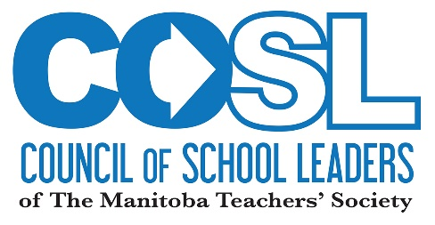
2018 - 2019
COSL MEETING DATES

Date | Meeting | Location
September 17, 2018 | Leadership Team | MPR, Bradley Square
September 28, 29 & 30, 2018 | COSL Directors Training | Holiday Inn Airport West
October 15, 2018 | Leadership Team | Brandon
Friday, October 19, 2018 | Fall Conference | Tec Voc
November 5, 2018 | Leadership Team | MPR, Bradley Square
Friday evening/Saturday  November 16 & 17, 2018 | COSL Directors | Auditorium, MTS
January 14, 2019 | Leadership Team | MPR, Bradley Square
Friday evening/Saturday  January 25 & 26, 2019 | COSL Directors | Auditorium, MTS
Thursday/Friday  February 14 & 15, 2019 | COSL Winter Conference | Fort Garry Hotel
February 25, 2019 | Leadership Team | MPR, Bradley Square
Friday evening/Saturday  March 15 & 16, 2019 | COSL Directors | Holiday Inn Airport West
April 8, 2019 | Leadership Team | MPR, Bradley Square
Friday evening/Saturday  May 10 & 11, 2019 | COSL 19th AGM | Auditorium, MTS
May 21, 2019 ( if required) | Leadership Team | MPR, Bradley Square
April 30 – May 3 | CAP Conference | Whitehorse, YT
Thursday/Friday/Saturday  May 22, 23, 24 & 25, 2019 | Provincial Council 2019 | Fairmont Winnipeg
Friday/Saturday  June 7 & 8, 2019 | Leadership Team | TBD

***Directors’ meetings commence at 7:00 p.m. on Fridays, and reconvene at 9:00 a.m. Saturday.

